|  |  |
| --- | --- |
|  | **FPT ACADEMY INTERNATIONAL**  **FPT – APTECH COMPUTER EDUCATION** |

**Centre Name: ACE-HCMC-2-FPT.**

**Address: 590 Cach Mang Thang 8, District 3, Ho Chi Minh City, Viet Nam.**

**Aquarium**

|  |  |  |
| --- | --- | --- |
| **Supervisor.** | Mr. Nguyen Phat Tai | |
| **Batch.** | T1.2209.E0 | |
| **Group.** | Group 4 | |
| **Serial No.** | **Enrollment Number** | **Student Name** |
| 1. | Student1414368 | Pham Tuan Minh |
| 2. | Student1420717 | Phan Vinh Thuan |
| 3. | Student1420708 | Nguyen Tuan Huy |
| 4. | Student1416064 | Nguyen Hoang Anh Minh |

Month 12 Year 2022

**This is to certify that**

**Mr.:**

Pham Tuan Minh

Phan Vinh Thuan

Nguyen Tuan Huy

**has successfully designed & developed**

eProject: AQUARIUM

**Submitted by: Phan Vinh Thuan**

**Date of issue: 14-December-2022**

**Authorized Signature: Thuan**

**TABLE OF CONTENTS**

ACKNOWLEGMENT 3

SYNOSIS 3

PROBLEM DEFINITION 3

CUSTOMER'S REQUIREMENTS SPECIFICATIONS (CRS) 4

Business/Project Objective: 4

Hardware/ Software Requirements: 4

SCOPE OF THE WORK (IN BRIEF) 5

Architecture and design of the system 6

Diagram of the website 7

TASK SHEET REVIEW 1 8

SITE MAP 9

MOCK OF THE WEBSITE 10

1. Home Page 10

2. About Us 11

3. Departments 12

4. Features 13

5. Contact Us 14

6. Vacancies 15

TASK SHEET REVIEW 2 16

WEBSITE DESCRIPTION 17

**1.** **Home Page** 17

**About aquarium** 17

2. events 19

We have plenty of events going on at Nexus 19

3. Activities 19

4. Plan 20

5. Library 21

HTML, CSS, JAVASCRIPT DESCRIPTION 21

TASK SHEET REVIEW 3 25

# ACKNOWLEGMENT

On behalf of all the members of group 4, I would like to acknowledge all those who have given moral support and helped me make the project a success.

I wish to express my gratitude to the eProjects Team at the Head Office, who guided and helped me. I also express my sincere gratitude to the eProjects Team at the Aptech Head Office and my project guide at the organization, for his valuable guidance and support for the completion of this project. Especially, Mr. Nguyen Phat Tai, our teacher, he has helped us a lot from the day he started teaching us. With this eProject, he has guided us with his enthusiasm and rigorous, because of his guiding, we would be able to finish this project. I would also like to express my gratitude to all the staff members of my center for not only providing me with the opportunity to work with them on this project, but also for their support and encouragement throughout the process.

And finally, I would like to offer many thanks to all the team member of group 1 for their valuable suggestions and constructive feedback, each of the team members has been working continuously in 4 weeks in order to complete this project. The last but not least, we would like to say thank you to our family for always supporting us, creating the best conditions for us to focus on the project, and putting faith in the dreams we pursue.

# SYNOSIS

Aquariums are popular attractions for people of all ages. They not only provide entertainment but also educate people about the environment and marine life. One of the most popular aquariums in Washington DC is the Aquarium.

The Aquarium is one of the largest aquariums in Washington DC, with more than 20,000 square feet of space. It was opened in 2013 and has been entertaining visitors ever since. The aquarium is home to more than 60 species of fish and other aquatic animals, including sharks, stingrays, lobsters, jellyfish, sea turtles and otters. Visitors can enjoy a variety of shows at this aquarium - from dolphin shows to educational presentations about marine life - as well as interactive exhibits that allow them to touch sharks or learn about fish habitats by walking through a transparent tunnel filled with water.

The Aquarium offers more than just entertainment - it also aims to educate visitors about marine life and environmental conservation efforts by hosting conservation-related events

The website is to be developed for the Windows Platform using HTML5, JavaScript and Geolocation. The site should work well in all leading browsers including Chrome, IE, Firefox etc.

# PROBLEM DEFINITION

The Web site is to be created based on the following requirements.

1. The Home page must have well defined logo and image of the sea creatures.
2. Apart from home link, other links such as gallery section, certain information about animals (marine life animals) they have.
3. Contact details must be added. Address of the Company should be displayed using GeoLocation API (eg. GoogleMaps) and the email address which when clicked will invoke the local mail client from where they can send an email.
4. Events (separately for children) must be stated in the website with the proper schedule and details.
5. Online booking of event (Dummy page where information must be entered, and validation checking must be done)
6. Timing and location must be stated in the website. Location should be displayed using GeoLocation API (eg. GoogleMaps)
7. Images of the aquarium location (site seeing must be included)
8. Navigation must be maintained smooth.
9. Color combination must be precise and uniformity must be maintained.
10. Categorization of the marine life animals and there different species information should be shown in tabular form.

Feedback form (dummy) should be provided

# CUSTOMER'S REQUIREMENTS SPECIFICATIONS (CRS)

**Client: AQUARIUM**

### Business/Project Objective:

The Objective of this program is to give a sample project to work on real life projects. These applications help you build a larger more robust application.

The objective is not to teach you JavaScript/Dreamweaver but to provide you with a real life scenario and help you create basic applications using the tools.

You can revise the chapters before you start with the project.

This project is meant for students who have completed the module of ***HTML5***. These programs should be done in the Lab sessions with assistance of the faculty if required.

It is very essential that a student has a clear understanding of the subject. Students should go through the project and solve the assignments as per requirements given.

Kindly get back @ [eprojects@aptech.ac.in](mailto:eprojects@aptech.ac.in) in case of any doubts regarding the application or its objectives.

**Input to the system:**

Browsing services based on brands, types of sightseeing and travel services

**Output from the system:**

* A menu that will categorize all the functions of the site.
* Display the list of available albums category wisely.
* Perform the search based on a particular: services,blog,…
* Site should be able to provide brief introduction/history about the aquarium under About page.
* The location of the aquarium under Contact page.
* Besides the above requirements, the site should have look and feel as per the industry standards.

**Expected delivery date:** 14-Jan-2023.

**List of deliverables:**

* + - * Document Word.
      * User Guide.
      * Source code.

### Hardware/ Software Requirements:

* **For developer**

**Hardware**

* A minimum computer system that will help you access all the tools in the courses is a Pentium 166 or better
* 64 Megabytes of RAM or better

**Software**

* Notepad/HTML editor
* Dreamweaver
* IE 5.0/ Netscape 6.0
* **For web users**

**Hardware**

* + Intel Pentium 4 processor or higher
  + 512 Megabytes of RAM or higher

**Software**

* + Windows XP OS or higher
  + Web browsers such as IE, Chrome or Firefox are supporting HTML5, CSS3 and Javascript.

# SCOPE OF THE WORK (IN BRIEF)

After a long and detailed discussion, our group has decided to create a website contain the following webpages:

1. **Homepage**: introduce the history of formation , founders and achievements (Also navigational link must be included.)
2. **Departments**: Display all department: services, pages,blog,contact,…
3. **Services**: Display the information of service: fish consultation , supply stock , planted tank , maintenance
4. **Centres**: Display the information about the aquarium , aquarium ecosystem,news and articles
5. **About Us**: Display the information about the aquarium and about us (including Academic information).
6. **Contact**: Display the address of the aquarium, allowing patients to query any information they want from Aquarium.

## Architecture and design of the system

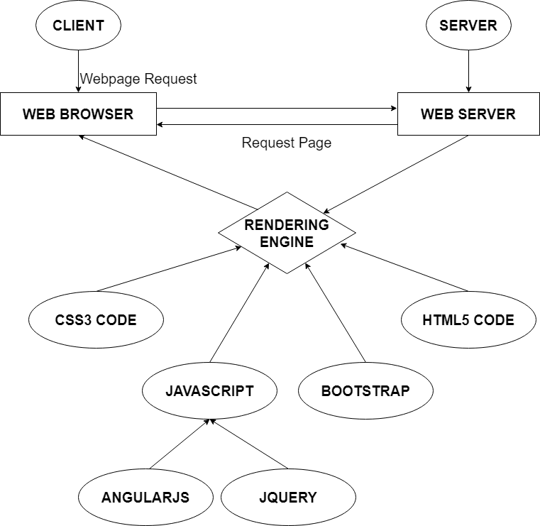

## Diagram of the website

HOME

ABOUT

BLOG

.

SERVICES

PAGES

CONTACT



# TASK SHEET REVIEW 1

|  |  |  |  |  |  |  |  |
| --- | --- | --- | --- | --- | --- | --- | --- |
| **Project Ref. No.:**  **eP/Advertisement Portal Management**  **System/01** | | **Project Title:** | **Activity Plan Prepared By:** | **Date of Preparation of Activity Plan:** | | | |
| **Sr.**  **No.** | **Task** | **Actual**  **Start Date** | **Actual Days** | **Team**  **Mate Names** | **Status** |
| 1 | Problem Statement | Aquarium | Thuan | 14-Dec-2022 | 1 | Minh | Completed |
| 2 | Analysis of Aquarium requirements about the website | 14-Dec-2022 | 1 | Minh | Completed |
| 3 | The scope of the work (in brief) | 14-Dec-2022 | 1 | Huy | Completed |
| 4 | Architecture and design of the system | 14-Dec-2022 | 1 | Thuan | Completed |
| 5 | Diagram of the website | 14-Dec-2022 | 1 | Thuan | Completed |
| 6 | Task Sheet | 14-Dec-2022 | 1 | Huy | Completed |

|  |  |
| --- | --- |
| **Date:** | |
| Signature of Instructor:  **Mr. Nguyen Phat Tai** | Signature of Team Leader:  **Mr. Phan Vinh Thuan** |

# SITE MAP



# MOCK OF THE WEBSITE

## 1. Home Page

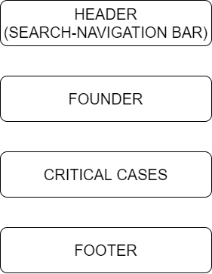

## 2. About Us

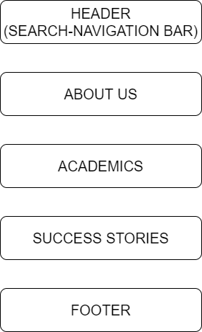

## 3. Departments

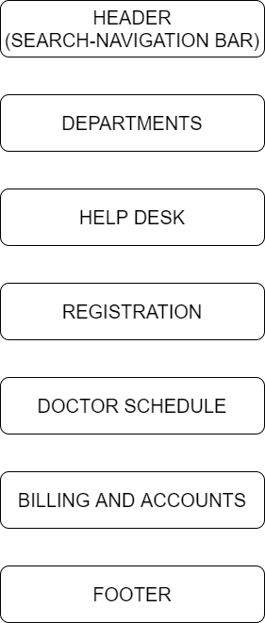

## 4. Features

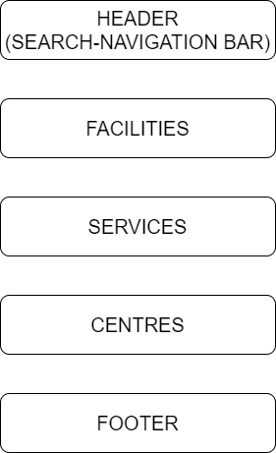

## 5. Contact Us

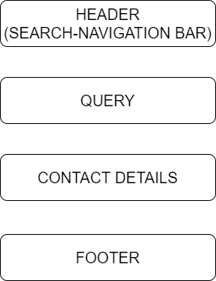

## 6. Vacancies

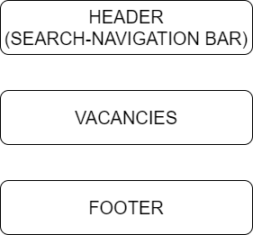

# TASK SHEET REVIEW 2

|  |  |  |  |  |  |  |  |
| --- | --- | --- | --- | --- | --- | --- | --- |
| **Project Ref. No.:**  **eP/Advertisement**  **Portal Management System/01** | | **Project Title:** | **Activity Plan Prepared By:** | **Date of Preparation of Activity Plan:** | | | |
| **Sr.**  **No.** | **Task** | **Actual Start Date** | **Actual Days** | **Team Mate Names** | **Status** |
| 1 | Site map | Nexus  Aquarium | Thuan | 30-Dec-22 | 1 | Huy | Completed |
| 2 | Mock of the website | 30-Dec-22 | 1 | Minh | Completed |
| 3 | Task sheet | 30-Dec-22 | 1 | Thuan | Completed |

|  |  |
| --- | --- |
| **Date:** | |
| Signature of Instructor:  **Mr. Nguyen Phat Tai** | Signature of Team Leader:  **Mr. Phan Vinh Thuan** |

# WEBSITE DESCRIPTION

1. **Home Page**

**About aquarium**

Our unique experiences

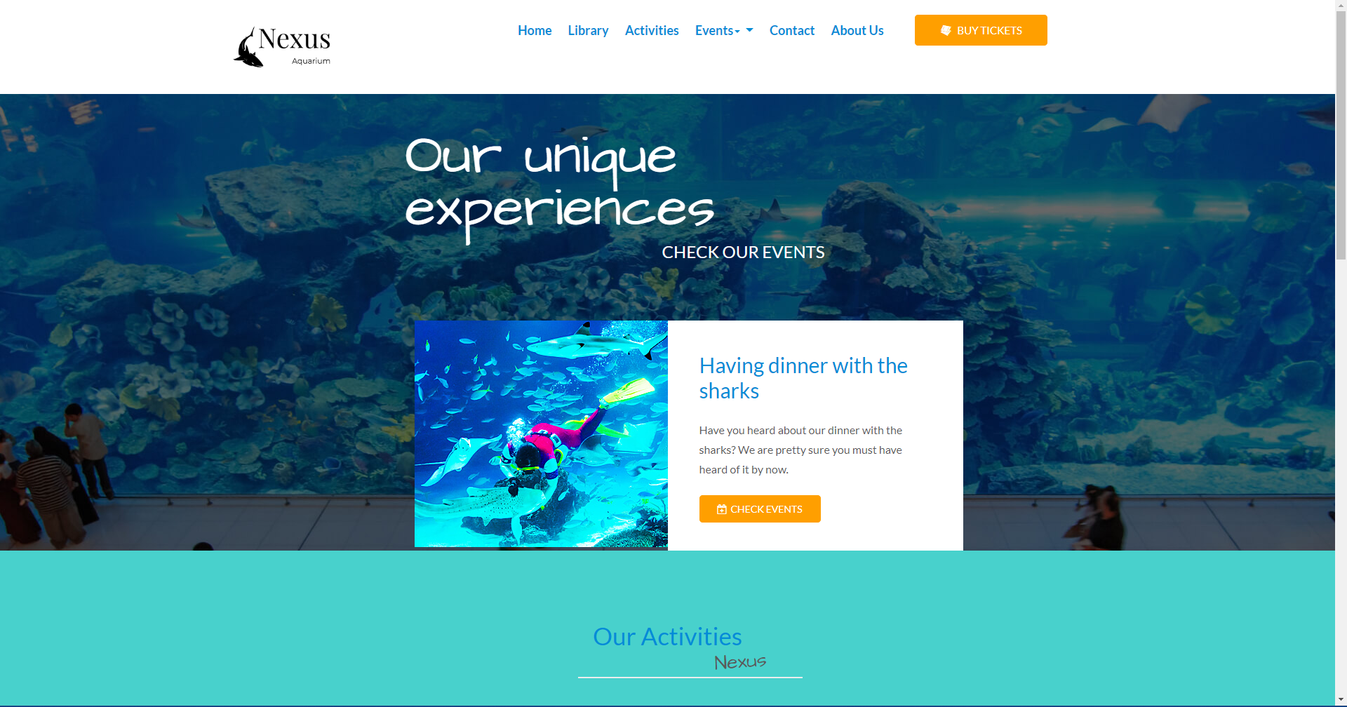

Information about the founder

Achievements :

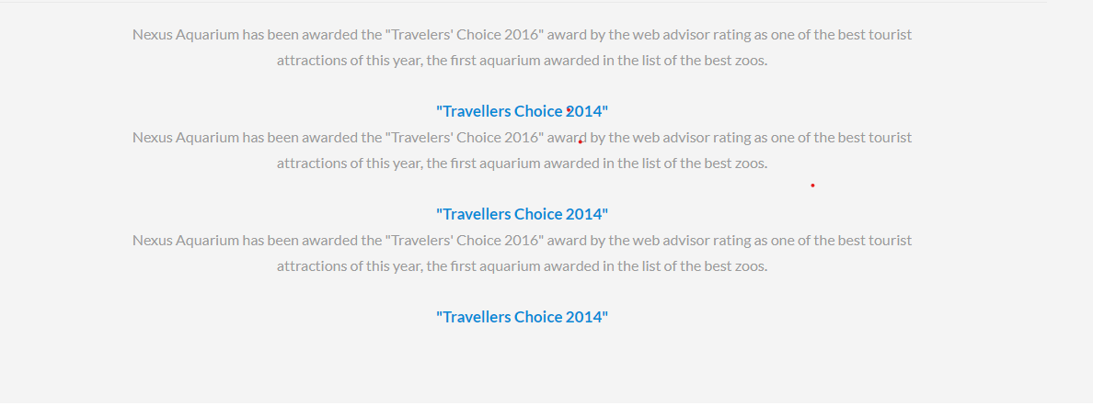

Footer

Contact Us ( on the side )

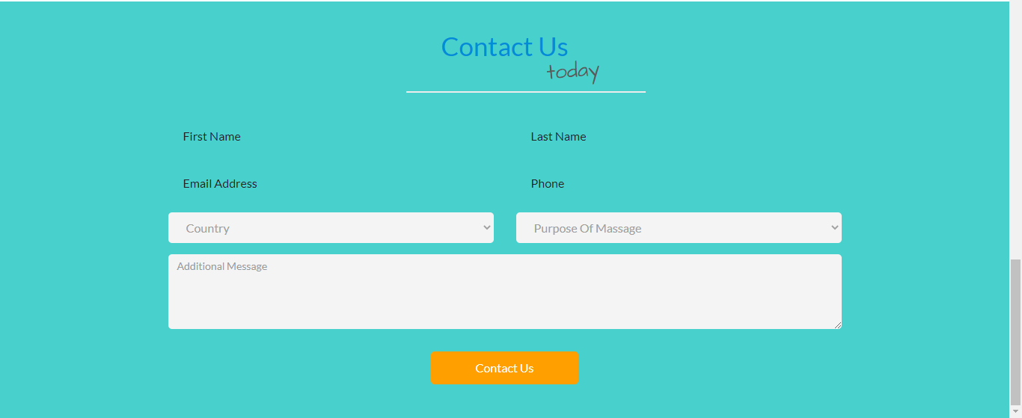

# events

## We have plenty of events going on at Nexus

Aquarium is not only a fascinating place to discover marine life, it is also a unique setting in which to delight your guests with a special event in the heart of Missouri.

* Auditorium
* Aqua Room
* Shows Hall
* Main Room

To enjoy an open-air setting with direct access from the Planeta Aqua Room, we offer our terrace.

With an area of 600 m² and spectacular views of the city and port, it is a space that offers a wide range of possibilities with which to project your ideas.

With a capacity of up to 450, it is an ideal venue for dinners, cocktail parties and presentations, and can be adapted to recreate different settings or host entertainment shows.

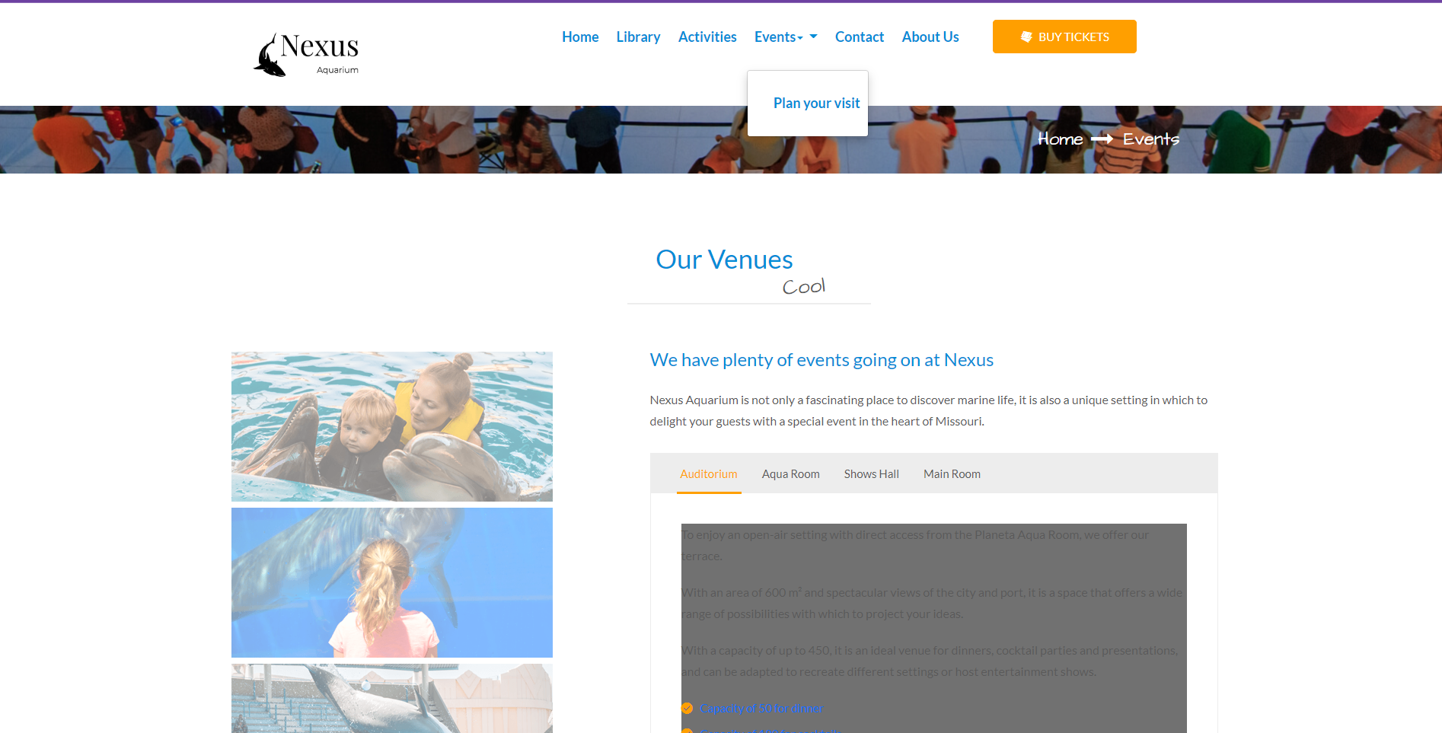

# Activities

* Wedding plans
* First communions
* Conferences and meetings
* Our professionals
* Catering service
* Team building

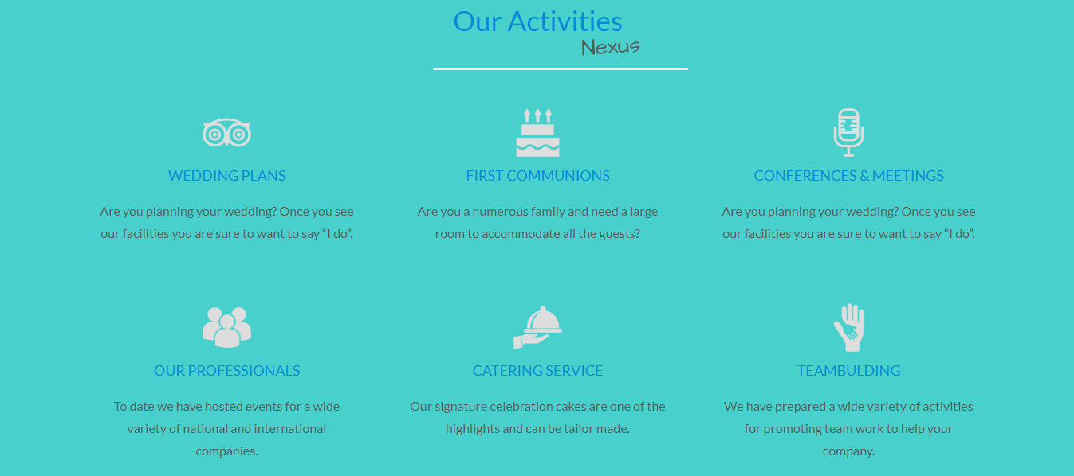

# Plan

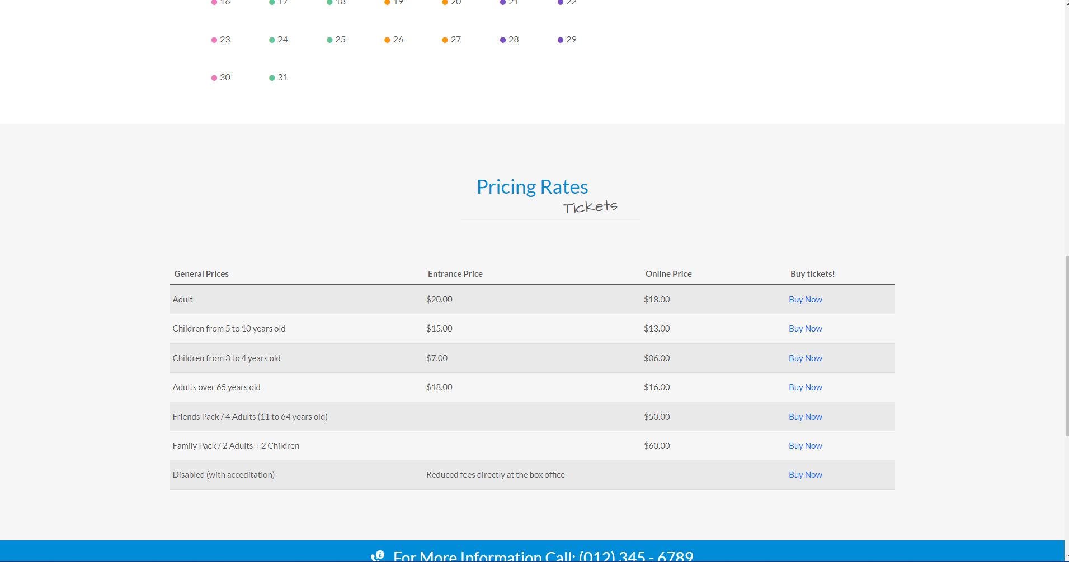

## Library

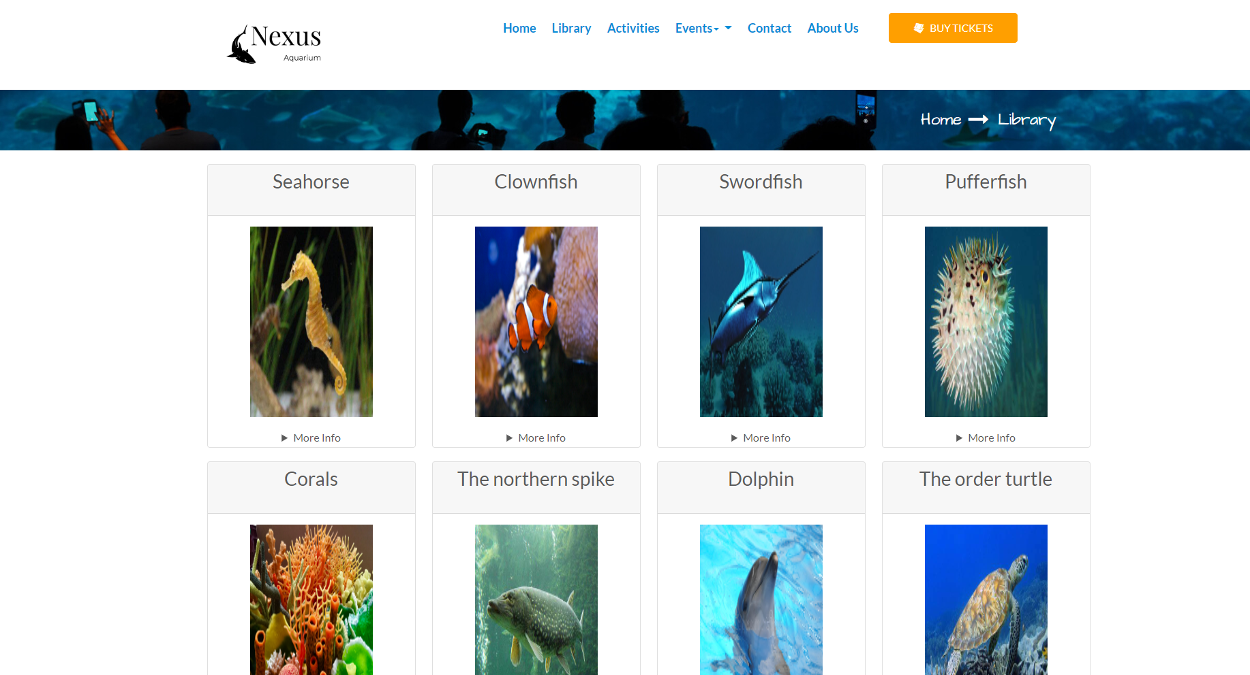

# HTML, CSS, JAVASCRIPT DESCRIPTION

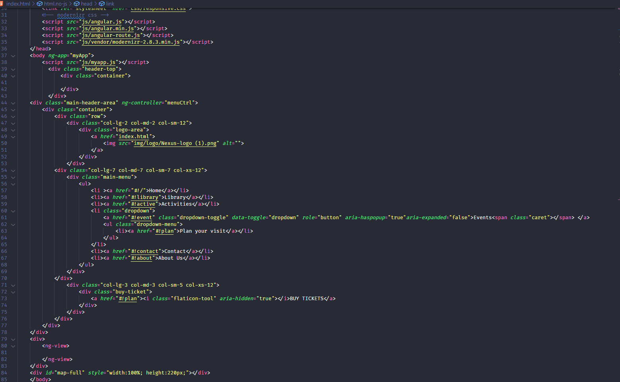

**INDEX**

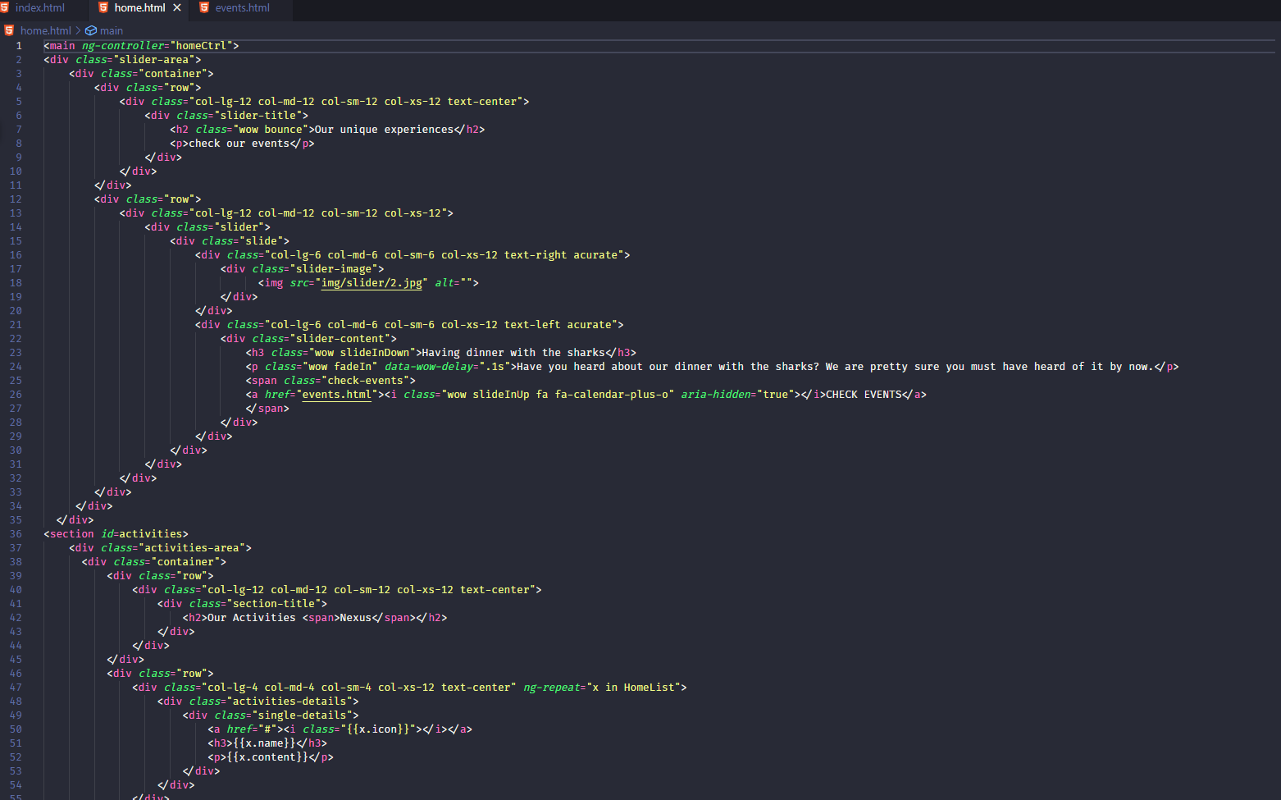**HOME PAGES**

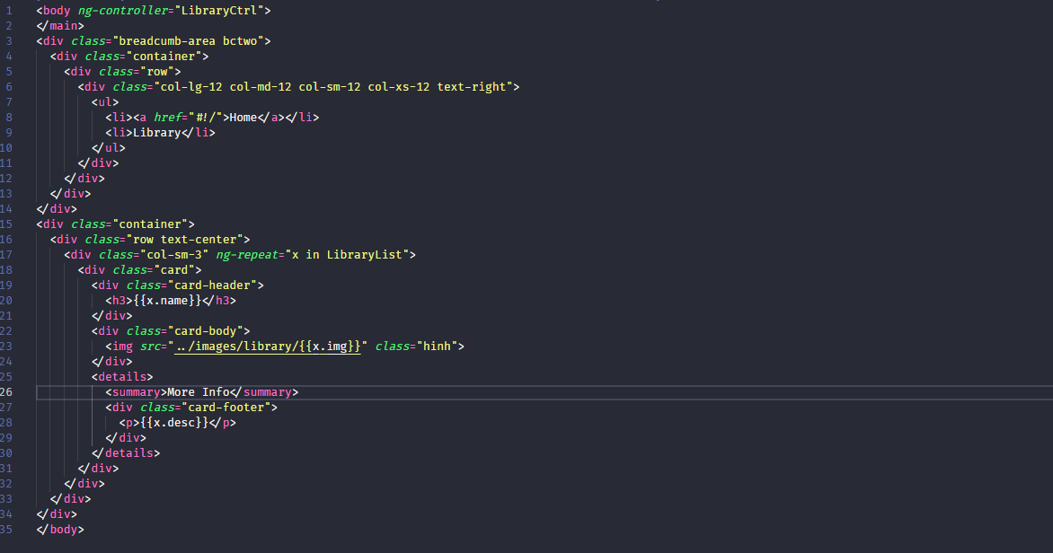**LIBRARY PAGES**

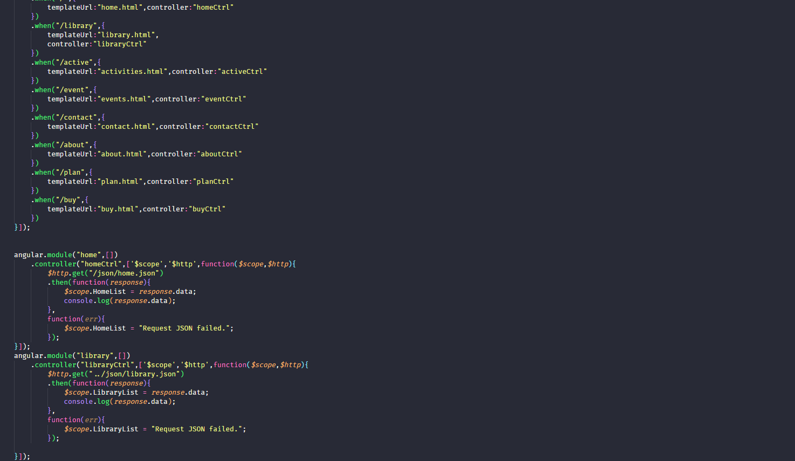

**MYAPP.JS**

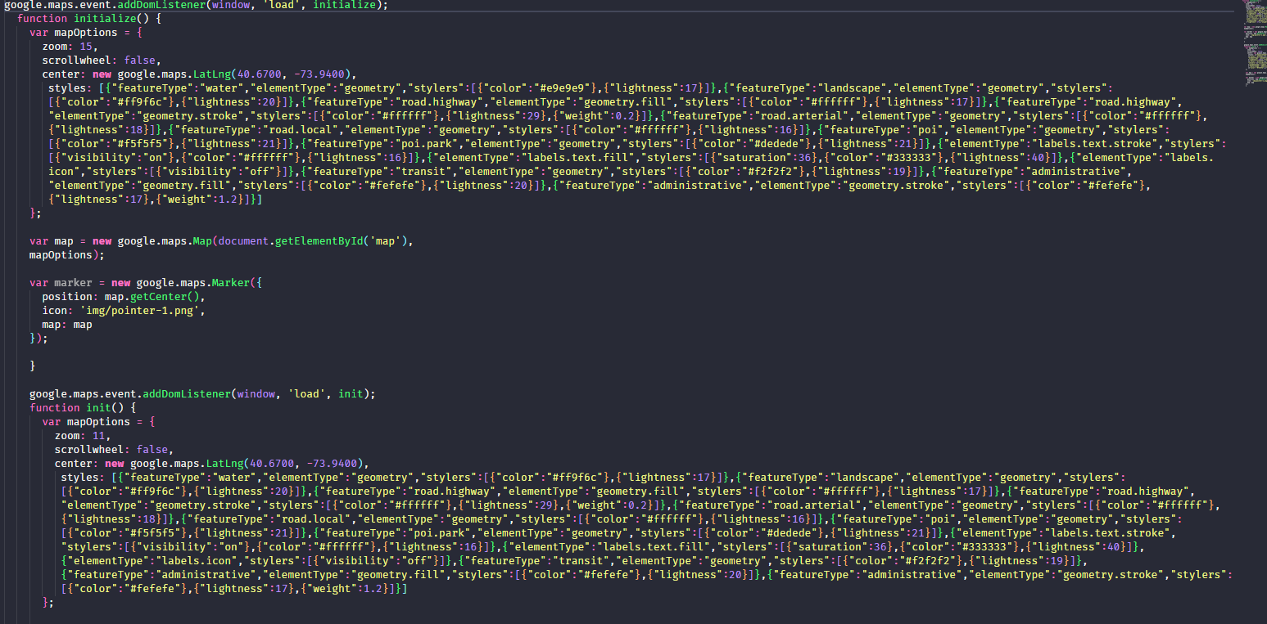

**GMAP FOR FOOTER**

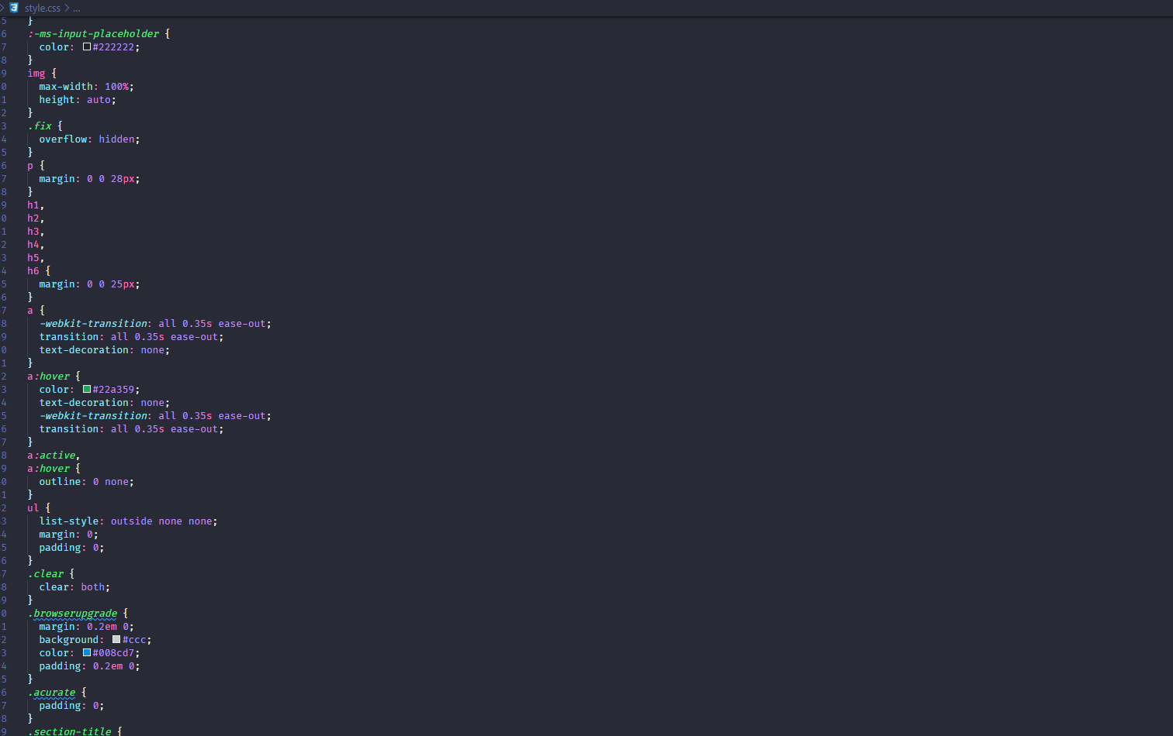

**DESIGN UX/UI FOR WEBSITE BY CSS**

# TASK SHEET REVIEW 3

|  |  |  |  |  |  |  |  |
| --- | --- | --- | --- | --- | --- | --- | --- |
| **Project Ref. No.:**  **eP/Advertisement Portal Management System/01** | | **Project Title:** | **Activity Plan Prepared By:** | **Date of Preparation of Activity Plan:** | | | |
| **Sr.**  **No.** | **Task** | **Actual Start**  **Date** | **Actual Days** | **Team Mate**  **Names** | **Status** |
| 1 | Home | **Aquarium** | **Thuan** | 6-Jan-22 | 2 | Tuan Minh | Completed |
| 2 | About Us | 6-Jan-21 | 2 | Thuan | Completed |
| 3 | Activities | 6-Jan-21 | 3 | Thuan | Completed |
| 4 | Library | 6-Jan-21 | 2 | Huy | Completed |
| 5 | Contact | 6-Jan-21 | 1 | Tuan Minh | Completed |
| 6 | Events |  |  | 6-Jan-21 | 1 | Tuan Minh | Completed |

|  |  |
| --- | --- |
| **Date: 8/10/2021** | |
| Signature of Instructor:  **Mr. Nguyen Phat Tai** | Signature of Team Leader:  **Mr. Phan Vinh Thuan** |